LAB 6 – CSS
At the end of this lab, students should be able to:
  - Design a web page by incorporating proper Cascading Style Sheet (CSS) property and values.
  - Use varieties of CSS properties and values to design the webpages.

Question 1
Write the External, Internal and Inline CSS codes for the following web page design. The HTML codes are already given.

Guides
- External CSS:
  - All elements in the whole webpage uses Verdana font.
  - Body of webpage:
    - Set a background colour of #F49C98.
  - The page-wrapper id:
    - Must be in the middle of the page.
    - The border and the content has a 10px space between them.
    - The width is 1100px.
    - Border thickness is 2px and the colour is F75A56.
    - Set the background colour as white.
    - There is a #F75A56 colour shadow that’s spreads 5px.
    - Round the corners by 10px.
  - The page-hori-navi id:
    - Background colour is #4CAF50 and the overflow is auto.
  - The hori-navi list:
    - There are no bullets, no padding and no margin.
  - The list item within the hori-navi list:
    - All the list items are located side by side (apply float).
  - All the hyperlinks in the list item within the hori-navi list:
    - Display as inline-block.
F
CI

1

    - The width is 200px.
    - Set top and bottom padding as 5px and left and right padding as 10px.
    - The text is yellow and center aligned.
    - No underlines are required.
  - When the mouse goes over all the hyperlinks in the list item within the horinavi list:
    - The background colour changes to #456ABC and the text colour changes to white.
  - The content id:
- Display it as flex and the direction is horizontal.

  - The left-column id:
    - The width is 230px.
    - Set 10px space between the border and the content.
  - The right-column id:
    - The width is 846px.
    - Set 10px space between the border and the content.
    - Set a 1px thick silver border.
  - The page-footer id:
    - Set 5px space between the border and the content.
    - The height is 70px.
    - The background colour is black.
    - The text is center aligned and white.
- Internal CSS:
  - The page-banner id:
    - The height is 300px.
    - Set a background image named banner.png.
    - Set a 2px thick silver border.
  - The vert-navi list:
    - The width is 180px.
    - Background colour is #F1F1F1.
    - There are no bullets and no padding
    - The list will be in the middle of the column.
  - All the hyperlinks in the list item within the vert-navi list:
    - Display as block.
    - The width is 180px.
    - Set top and bottom padding as 5px and left and right padding as 10px.
F
CI

2

    - The text is blue and center aligned.
    - No underlines are required.
  - When the mouse goes over all the hyperlinks in the list item within the vertnavi list:
    - The background colour changes to #555 and the text colour changes to white.
- Inline CSS:
  - The paragraph in the footer must be orange with a Arial Narrow font.

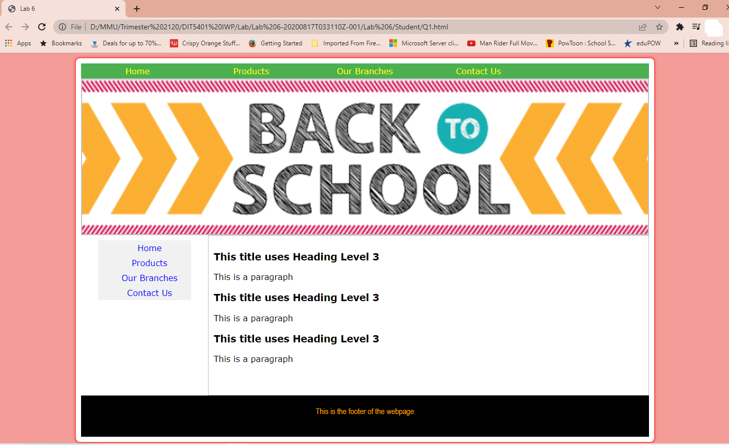

When mouse over the hyperlink in hori-navi list:
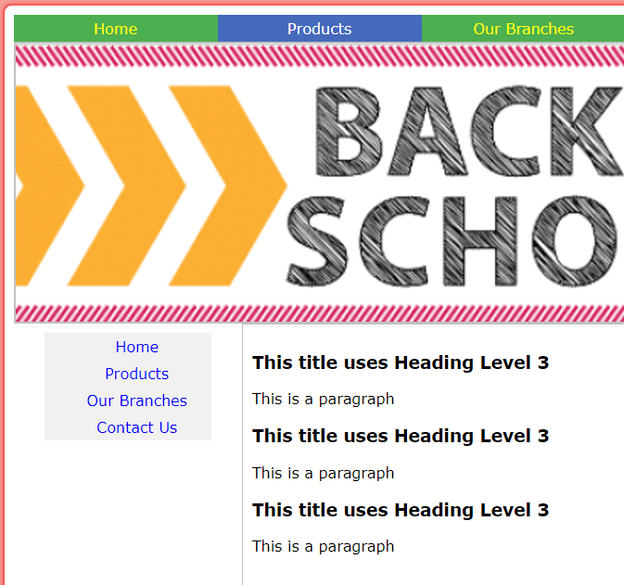

When mouse over the hyperlink in vert-navi list:
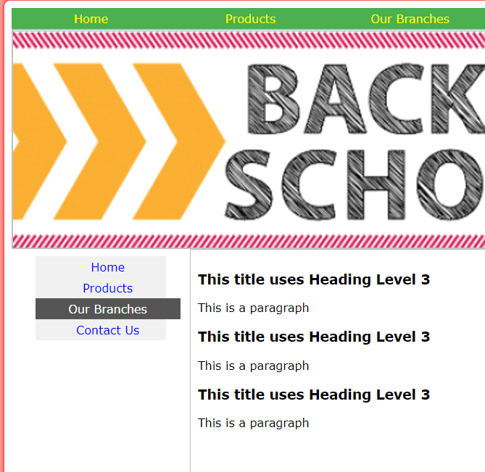
Question 2
Write the Internal and Inline CSS codes for the following web page design. The HTML codes are already given.
Guides
- Internal CSS
  - The login-title id:
    - The height is 40px.
    - The background colour is #DDD.
    - The background image is padlock.png.
    - Adjust the background image position(7 px 7 px) and size(24 px 24 px) accordingly.
    - The top left and top right corners are curved by 8px.
  - The login-form id:
    - Set 10px padding and center the text.
  - The email and password input type elements within the login-form id.
    - The width is 250px and height is 25px.
    - There is 1px #DDD colour solid border.
    - The corners are rounded by 5px.
    - Set top and bottom padding of 5px, right padding is 10px and left padding is 40px.
  - Set an email icon in the email type input element.
    - Adjust the background image position (email icon) -10px 10px
  - Set a key icon in the password type input element.
    - Adjust the background image position (key icon) -10px 10px
  - The submit button in the login-form id:
    - The background colour is #0066FF and the text colour is white and bold.
    - The width is 300px with 10px padding.
    - No borders required.
  - When the mouse goes over the submit button in the login-form id:
    - The background colour changes to #2C61B7 and the cursor changes to a pointer(cursor).
  - The hyperlink within the paragraph in the login-form id:
    - No underlines required.
    - Text are Arial Narrow with a size of 0.8em and center aligned.
  - When the mouse goes over the hyperlink within the paragraph in the login-form id:
    - The text becomes italic and red.

- Inline CSS
  - The main <div>:
    - The width is 400px with no padding.
    - It is centered(margin:auto) with a 1px #DDD color border.
    - Border corners are curved by 10px.
  - The heading level 4 within the login-title id:
    - The text is blue with Arial font.
    - No margin required.
    - The top and bottom padding is 12px and the left and right padding is 40px.

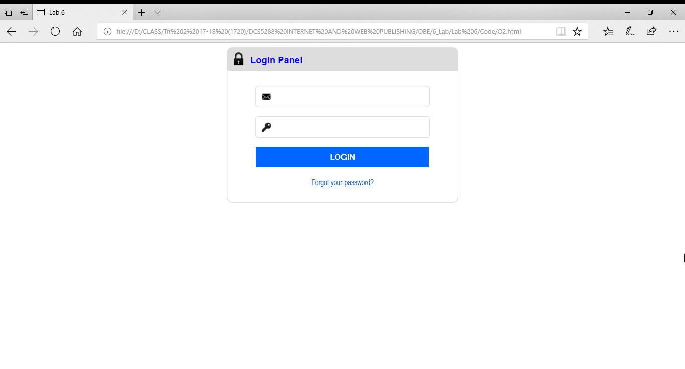
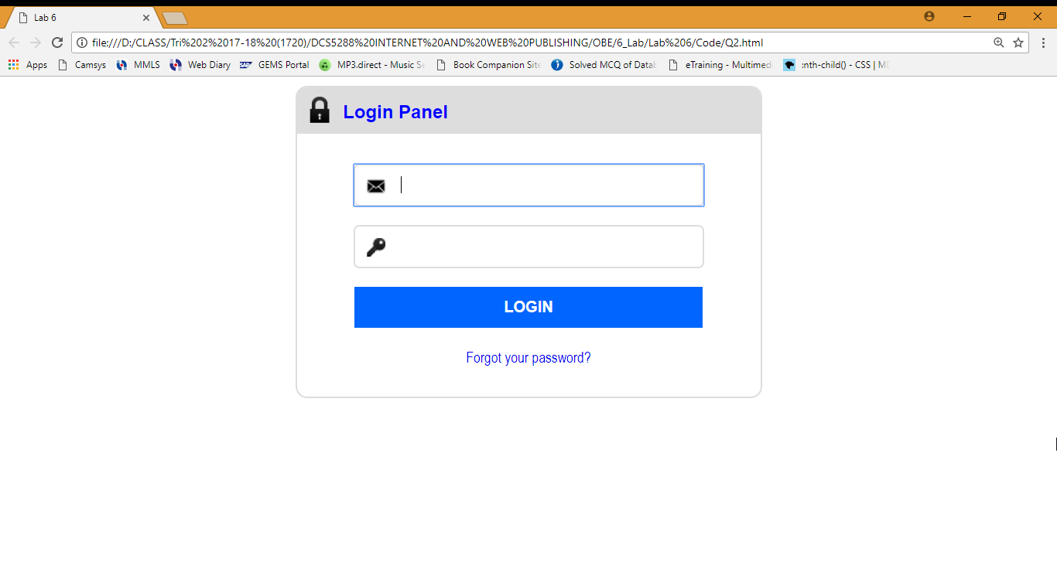
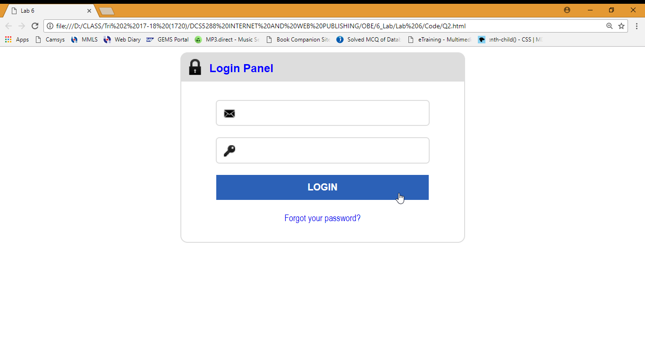
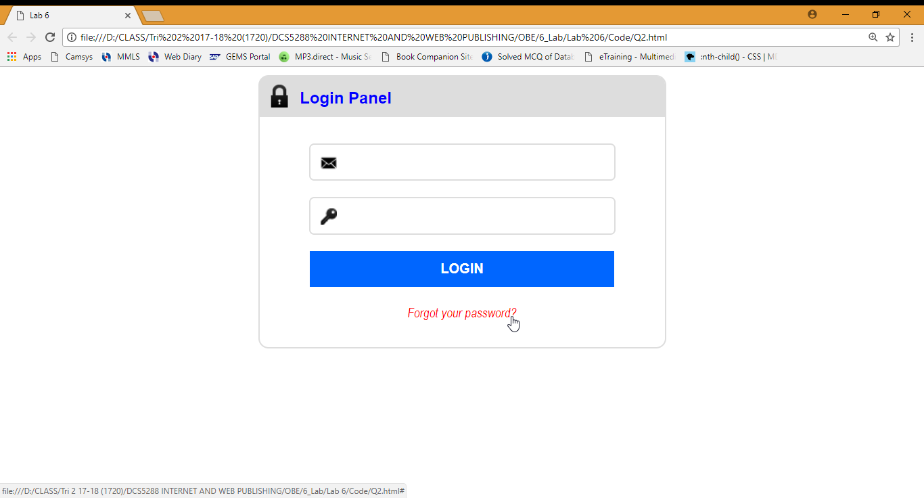

Question 3
Write the Internal and Inline CSS codes for the following web page design. The HTML codes are already given.
Guides
- Internal CSS.
  - All fonts in this webpage is Verdana.
  - Heading level 3 text colour is green.
  - The fieldset selector:
    - The width is 600px witdh a 2px thick red border.
    - Put a #CCC colour shadow(box shadow).
  - The label selector:
    - Float to left.
    - The width is 150px and right aligned.
    - Font is blue and bold with a size of 0.8em.
    - Set a right-margin of 10px.
  - The hint class:
    - Display as block.
    - Font is red without bold and the size is 0.7em.
    - Set a 5px right margin.
  - All the input boxes(email and text) and textarea:
    - The borders are 1px thick and gray.
    - The height is 20px.
    - The top and bottom padding is 5px while the right and left is 15px.
  - When the cursor is in the input boxes(email and text) and textarea:
    - The border changes to 1px thick and blue.
  - The submit and reset buttons:
    - Has orange background and white text.
    - The width is 100px with 1px orange border.
    - The top and bottom padding is 10px while the left and right padding is 20px.
  - When the mouse goes over the buttons(submit & reset):
    - The cursor changes to a pointer and the buttons becomes transparent(opacity:0.6).

- Inline CSS.
  - The first paragraph is in italic.
  - The last paragraph has a #BBB colour and the size is 0.7em.

